**SQL Case Study 1: Data Mart Analysis**



INTRODUCTION

Data Dart is my latest venture and I want your help to analyze the sales and performance of my venture. In June 2020 - large scale supply changes were made at Data Mart. All Data Mart products now use sustainable packaging methods in every single step from the farm all the way to the customer.

I need your help to quantify the impact of this change on the sales performance for Data Mart and its separate business areas.

**Done By : L. ANUSH BHARATHWAJ**

**[LINK](https://drive.google.com/drive/folders/1-dulIJKUcYr8jP4K3hGkcPVH5NO-xKj6?usp=sharing)**

SCHEMA USED

**WEEKLY_SALES TABLE**

|  |  |
| --- | --- |
| Column name | Data type |
| week_date | date |
| region | varchar(20) |
| platform | varchar(20) |
| segment | varchar(10) |
| customer | varchar(20) |
| transactions | int |
| sales | int |

CASE STUDY QUESTIONS

## **Data Cleansing Steps**

**In a single query, perform the following operations and generate a new table in the data_mart schema named clean_weekly_sales:**

1. **Add a week_number as the second column for each week_date value, for example any value from the 1st of January to 7th of January will be 1, 8th to 14th will be 2, etc.**
2. **Add a month_number with the calendar month for each week_date value as the 3rd column.**
3. **Add a calendar_year column as the 4th column containing either 2018, 2019 or 2020 values.**
4. **Add a new column called age_band after the original segment column using the following mapping on the number inside the segment value.**

|  |  |
| --- | --- |
| segment | age_band |
| 1 | Young Adults |
| 2 | Middle Aged |
| 3 or 4 | Retirees |

1. **Add a new demographic column using the following mapping for the first letter in the segment values:**

|  |
| --- |
| **segment | demographic |** |
| **C | Couples |** |
| **F | Families |** |

1. **Ensure all null string values with an "unknown" string value in the original segment column as well as the new age_band and demographic columns.**
2. **Generate a new avg_transaction column as the sales value divided by transactions rounded to 2 decimal places for each record.**

**create table clean_weekly_sales as**

**select**

**week_date,**

**week(week_date) as week_number ,**

**month(week_date) as month_number,**

**monthname(week_date) as month_name,**

**year(week_date) as calendar_year,**

**case**

**when segment='null' then 'Unknown'**

**else segment**

**end as 'segment',**

**case**

**when Right(segment,1)= '1' then 'Young Adults'**

**when Right(segment,1)= '2' then 'Middle Aged'**

**when Right(segment,1) in ('3','4') then 'Retirees'**

**else 'Unknown'**

**end as 'age_band',**

**case**

**when Left(segment,1)='C' then 'Couples'**

**when Left(segment,1)='F' then 'Families'**

**else 'Unknown'**

**end as 'demographic',**

**platform,**

**region,**

**Round(sales/transactions,2) as 'avg_transaction',**

**transactions,**

**sales**

**from weekly_sales;**

**select * from clean_weekly_sales limit 10;**

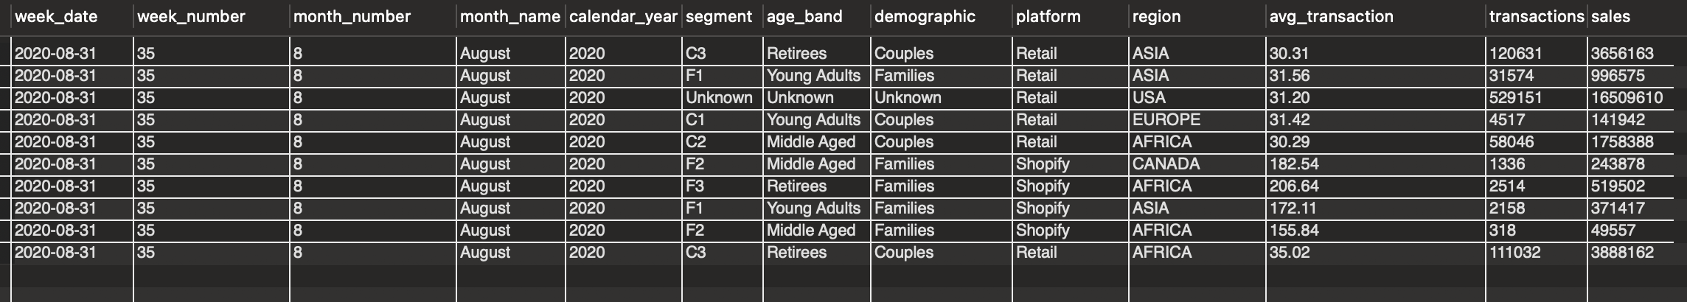

## **B. Data Exploration**

1. **Which week numbers are missing from the dataset?**

**create table seq100(x int auto_increment primary key);**

**insert into seq100 values (),(),(),(),(),(),(),(),(),();**

**insert into seq100 values (),(),(),(),(),(),(),(),(),();**

**insert into seq100 values (),(),(),(),(),(),(),(),(),();**

**insert into seq100 values (),(),(),(),(),(),(),(),(),();**

**insert into seq100 values (),(),(),(),(),(),(),(),(),();**

**insert into seq100 select x+50 from seq100;**

**select * from seq100;**

**create table seq52 as select x from seq100 limit 52;**

**select * from seq52;**

**select x as 'Miss_week_numbers' from seq52 where x not in (select distinct week_number from clean_weekly_sales);**

1. **How many total transactions were there for each year in the dataset?**

**select calendar_year as 'Year' ,sum(avg_transaction) as 'Total Transactions' from clean_weekly_sales group by Year;**

1. **What are the total sales for each region for each month?**

**select month_name , month_number ,region ,sum(sales) from clean_weekly_sales group by month_name, month_number,region;**

1. **What is the total count of transactions for each platform?**

**select platform , count(transactions) from clean_weekly_sales group by platform;**

**select platform , sum(transactions) from clean_weekly_sales group by platform;**

1. **What is the percentage of sales for Retail vs Shopify for each month?**

**with cte_montly_sales as**

**( select month_number , calendar_year , platform , SUM(sales) as saless from clean_weekly_sales group by month_number , calendar_year , platform )**

**select month_number , calendar_year ,**

**ROUND( 100 * MAX(case when platform = 'Retail' then saless else NULL end) / SUM(saless),2) as 'retail_perc',**

**ROUND( 100 * MAX(case when platform = 'Shopify' then saless else NULL end) / SUM(saless),2) as 'shopify_perc'**

**from cte_montly_sales**

**group by month_number , calendar_year**

**order by month_number , calendar_year ;**

1. **What is the percentage of sales by demographic for each year in the dataset?**

**select calendar_year, demographic , sum(sales) as year_sales, round( 100 * sum(sales)/sum(sum(sales)) over(partition by demographic),2)as perc from clean_weekly_sales**

**group by calendar_year, demographic**

**order by calendar_year, demographic;**

1. **Which age_band and demographic values contribute the most to Retail sales?**

**select age_band , demographic , sum(sales) as Sales from clean_weekly_sales where platform = 'Retail' group by age_band , demographic order by Sales desc;**

